ACSL
American Computer Science League
2013 - 2014

Contest #3

Senior Division Solutions

- Boolean Algebra
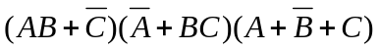 =
= 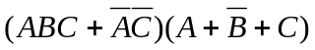
=
= 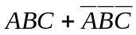

1. (1, 1, 1)
(0, 0, 0)

2. 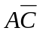
- Boolean Algebra

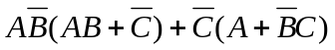=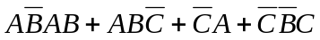
=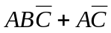=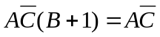

3. 24
- Graph Theory
1  1 | 1 | 3 |  | 4 | 4 | 4
0 | 1 | 1 |  | = | 2 | 2 | 2
1 | 0 | 0 |  |  | 2 | 2 | 2

Cubing the adjacency matrix results in the number of paths of
length 3 between vertices. Adding all the entries gives the total.
1
0
0
1
0
=
2
3
7
2
3
0
1
1
0
1
9
2
8
7
2
1
0
1
0
0
4
1
4
3
1

Therefore no path of length 4 exists between A & B and A & E

4. 5
- Graph Theory
There are 5 cycles from A: ABCA, ABDA, ABDCA, ADA, and ADCA.

- Bit-String Flicking
Let X = abcde
LHS = (LSHIFT-2 (RCIRC-1 01110)) OR (LCIRC-2 (RSHIFT-1 abcde))
AND (NOT(RCIRC-1 (LSHIFT-2 01010)))
= (LSHIFT-2 00111) OR (LCIRC-2 0abcd) AND (NOT(RCIRC-1 01000))
= 11100 OR bcd0a AND (NOT 00100) = 11100 OR bcd0a AND 11011
= 11100 OR bc00a = 1110a
RHS = (LCIRC-2 (NOT 10000)) = (LCIRC-2 01111) = 11101

1110a = 11101→ a = 1, b = *, c = *, d = *, e = * → 1****

5. 1****

